Sales Analytics
PROJECT REPORT

1. Overview of the Project
This Sales Analytics project focuses on analyzing transactional business data using SQL for exploratory data analysis and Power BI for interactive dashboard visualization.
The project evaluates customer behavior, product performance, supplier contribution, revenue trends, and geographic distribution to support data-driven business decision-making.
Four dashboards were developed:
- Customer Analysis Dashboard
- Sales Dashboard
- Product Analysis Dashboard
- Supplier Dashboard

2. Objective
The key objectives of this project are:
- To analyze customer purchasing behavior and distribution
- To identify revenue trends and seasonal patterns
- To evaluate product and category performance
- To examine supplier pricing and geographic coverage
- To detect anomalies in revenue
- To support strategic business recommendations

3. Significance
This project demonstrates how business intelligence tools can:
- Identify high-value customers
- Optimize product inventory
- Detect revenue fluctuations
- Evaluate supplier performance
- Improve operational planning
Using SQL and Power BI together strengthens analytical accuracy and visualization clarity.

4. Data Dictionary
The dataset consists of the following key tables:
- Customers – CustomerID, Country, City, ContactTitle
- Orders – OrderID, CustomerID, EmployeeID, OrderDate, ShippedDate
- Order Details – OrderID, ProductID, Quantity, UnitPrice
- Products – ProductID, CategoryID, SupplierID, UnitPrice, UnitsInStock
- Categories – CategoryID, CategoryName
- Suppliers – SupplierID, CompanyName, Country
- Employees – EmployeeID, Title, HireDate
- Shippers – ShipperID, CompanyName

5. ER Diagram
The model follows a relational star schema:
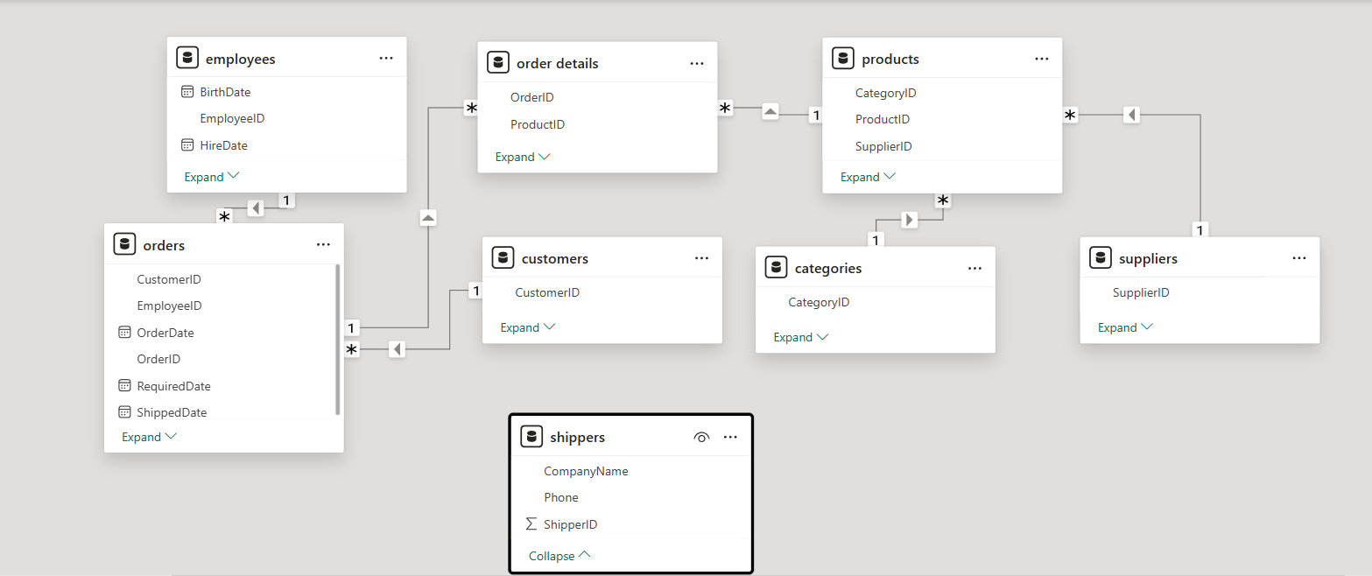
- Customers → Orders (1:M)
- Employees → Orders (1:M)
- Orders → Order Details (1:M)
- Products → Order Details (1:M)
- Categories → Products (1:M)
- Suppliers → Products (1:M)
Orders and Order Details act as fact tables, while others serve as dimension tables. This structure ensures efficient aggregation and filtering in Power BI.

6. Steps to Connect to Data
- Imported Excel dataset into Power BI
- Cleaned data using Power Query
  - Removed null values
  - Standardized date formats
  - Corrected numeric data types
- Created relationships between tables
- Built DAX measures:
  - Total Revenue
  - Average Order per Customer
  - Average Monthly Revenue
  - Highest Monthly Revenue
  - Total Stock
- Designed four interactive dashboards

7. Exploratory Data Analysis Using SQL
SQL queries were executed to perform exploratory data analysis and validate key business metrics before visualization. The analysis addressed the following areas:
- Calculated the average number of orders per customer and identified high-value repeat customers based on total revenue contribution.
- Analyzed monthly order trends to detect seasonal patterns and fluctuations in demand.
- Determined revenue contribution by product category to identify revenue-driving segments.
- Compared supplier pricing across regions to assess cost variations and potential negotiation opportunities.
- Computed average shipping duration to evaluate operational efficiency.
These SQL-based validations ensured data integrity, consistency, and reliability before

8. Dashboard Analysis & Insights

8.1 Customer Analysis Dashboard
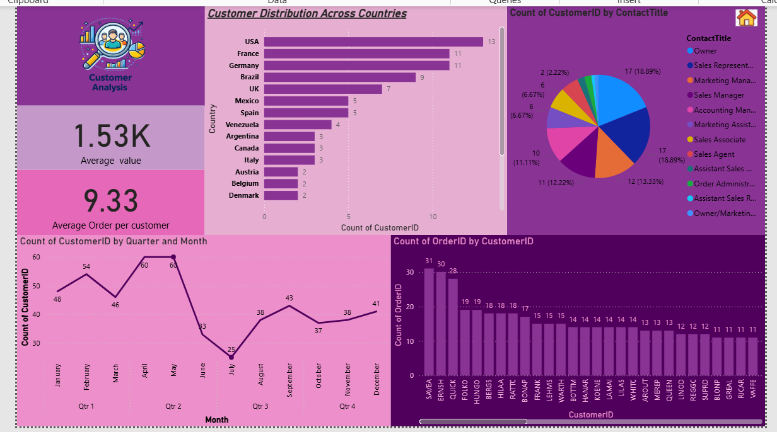
Key Metrics:
- Average Revenue Value: 1.53K
- Average Orders per Customer: 9.33
Insights:
- USA has the highest customer count (13), followed by France and Germany (11 each).
- Order volume peaked in April–May and dropped significantly in July.
- Customer distribution by contact title shows Owners and Sales Representatives form a major share.
- Some customers place significantly more orders (top customer: 31 orders), indicating repeat high-value customers.
Business Insight:
Customer concentration exists in specific countries, and a small segment of customers drives repeated purchases.

8.2 Sales Dashboard
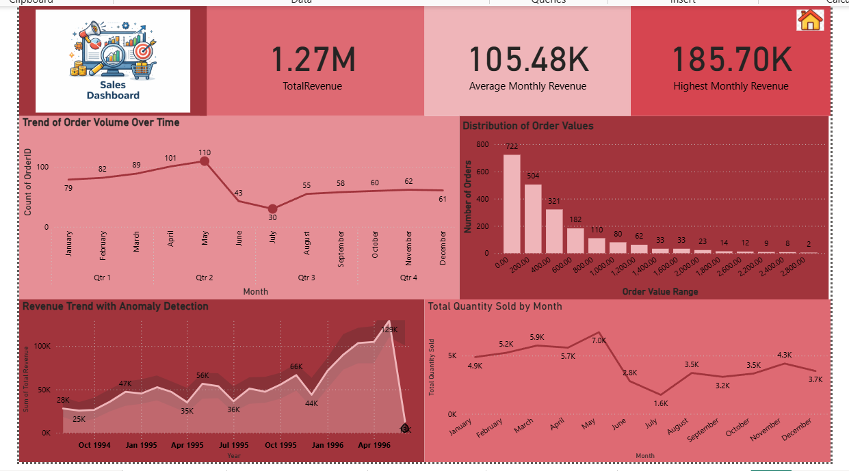
Key Metrics:
- Total Revenue: 1.27M
- Average Monthly Revenue: 105.48K
- Highest Monthly Revenue: 185.70K
Insights:
- Order volume peaked in May (110 orders).
- Revenue anomaly detected around early 1996 (significant spike).
- Majority of orders fall within lower value ranges (0–2000).
- Total quantity sold peaked in May (7.0K units) and dropped sharply in July (1.6K).
Business Insight:
Seasonal trends strongly influence both revenue and sales volume. Monitoring anomalies is important for forecasting accuracy.

8.3 Product Analysis Dashboard
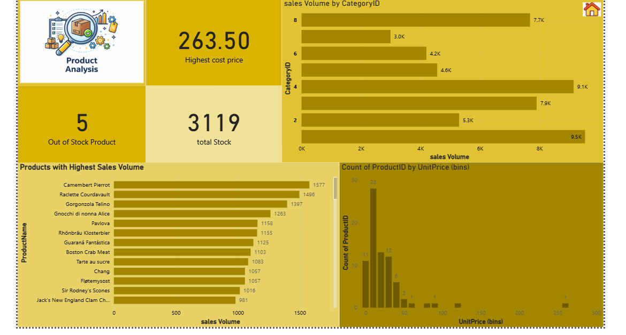
Key Metrics:
- Highest Product Price: 263.50
- Out-of-Stock Products: 5
- Total Stock: 3119
Insights:
- Category 2 and Category 4 contribute highest sales volume.
- Top product (Camembert Pierrot) shows highest sales volume (1577 units).
- Most products fall within lower price ranges.
Business Insight:
High sales volume products are not necessarily high-priced products. Inventory monitoring is crucial to avoid stock-outs.

8.4 Supplier Dashboard
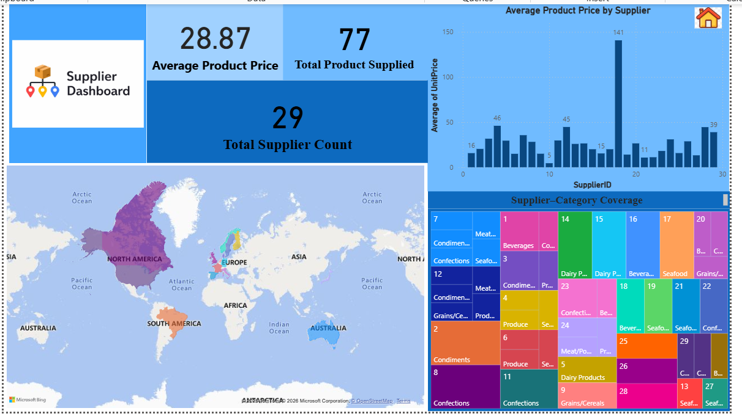
Key Metrics:
- Average Product Price: 28.87
- Total Products Supplied: 77
- Total Suppliers: 29
Insights:
- Supplier pricing varies significantly (one supplier avg price = 141).
- Suppliers are geographically concentrated in North America and Europe.
- Some suppliers specialize in specific categories like Dairy and Confections.
Business Insight:
Supplier diversification can reduce pricing risk and improve negotiation leverage.

9. Overall Key Findings
- Revenue is driven by repeat customers.
- Seasonal patterns affect both sales and revenue.
- Product demand varies significantly by category.
- Supplier pricing differences impact profitability.
- Geographic concentration exists in customers and suppliers.

10. Conclusion
The Sales Analytics project successfully integrates SQL-based exploratory analysis with Power BI visualization to generate comprehensive business insights.
Through structured modeling and dashboard design, the project highlights:
- Customer concentration trends
- Revenue seasonality
- Product performance differences
- Supplier pricing variation
- Inventory and stock insights
This analysis supports strategic decision-making and demonstrates the value of data-driven business intelligence.

